1. What is Google Dorking?

Google docking, also known as google hacking, is a technique that utilizes advanced search operators to uncover information on the internet that may not be readily available through standard search queries

Sample shots :

* site:uber.com inurl:login - Advanced search operator

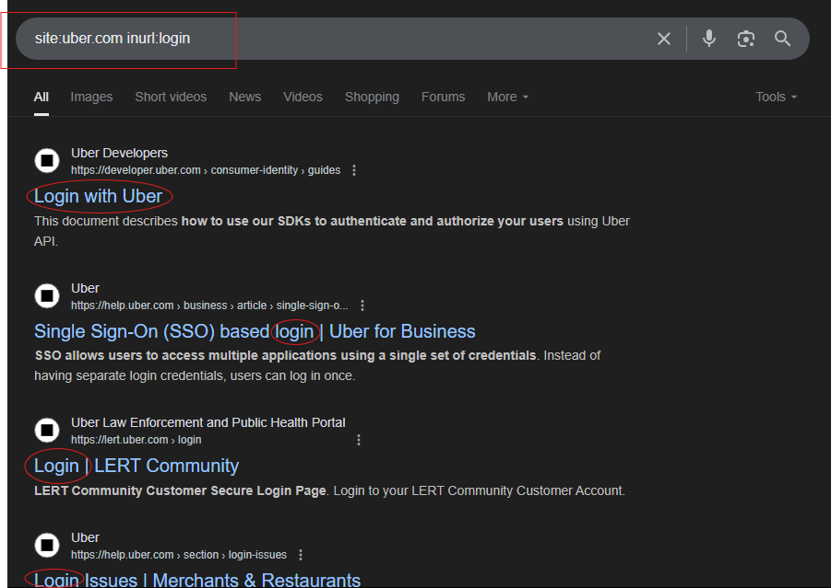

* site:uber.com intext:"cab" - Advanced search operator

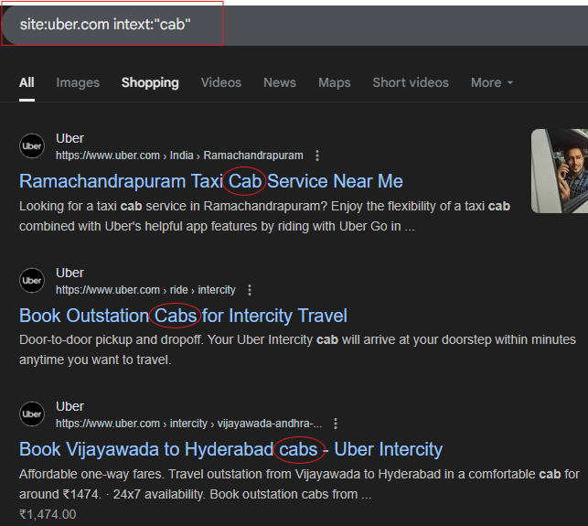

1. Look for sensitive file on any target.

* By using search operator we can access the sensitive data of a company as shown in the screenshot below. Here we are able to access SLA of Uber company which is confidential.

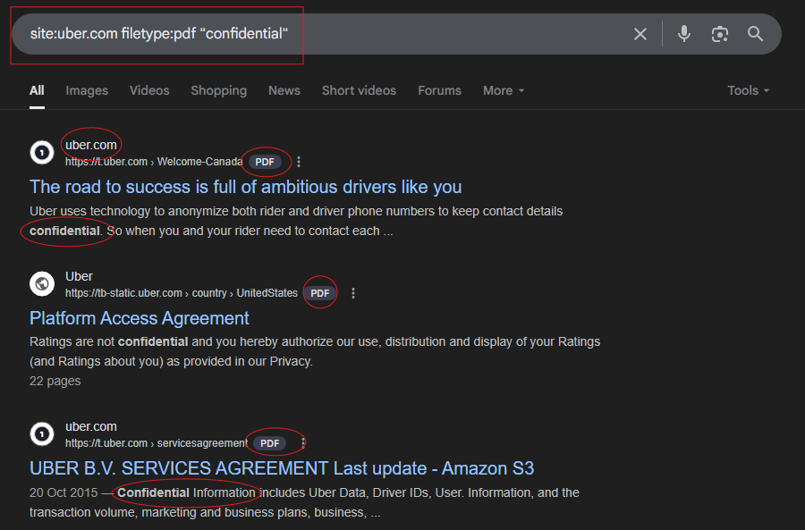

* site:facebook.com filetype:xml - Advanced search operator

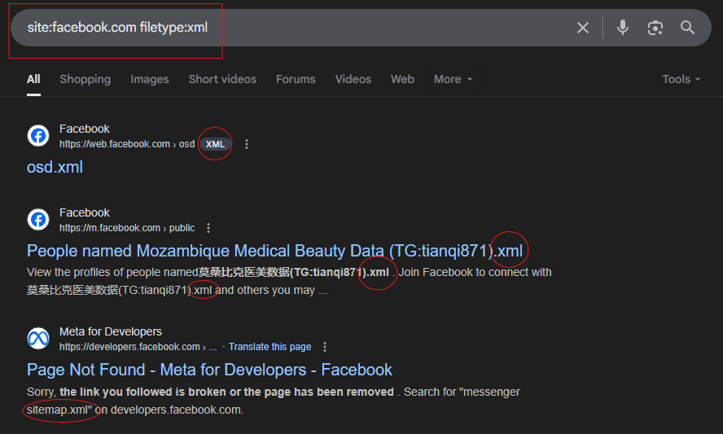

1. Try to create a custom google dork - login page, cameras, backup directories

* intitle:"Administrator Login" - Advanced search operator

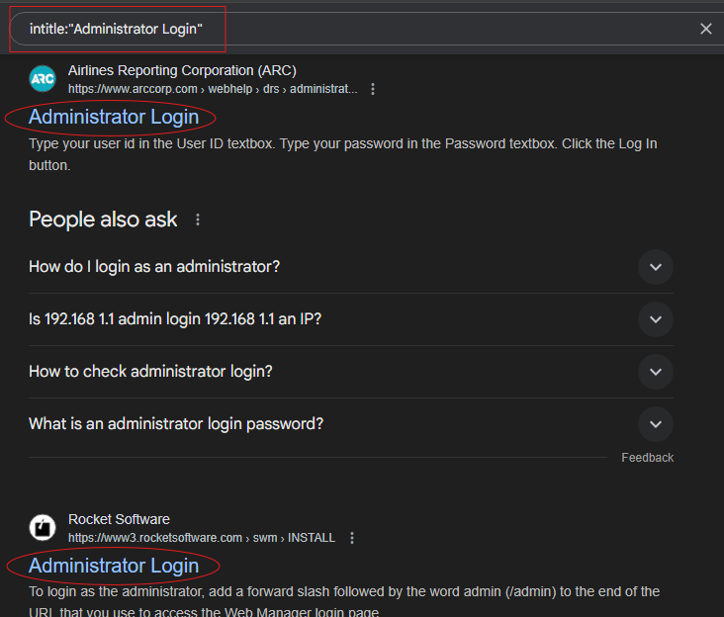

* intitle:"cPanel" "Login" - Advanced search operator

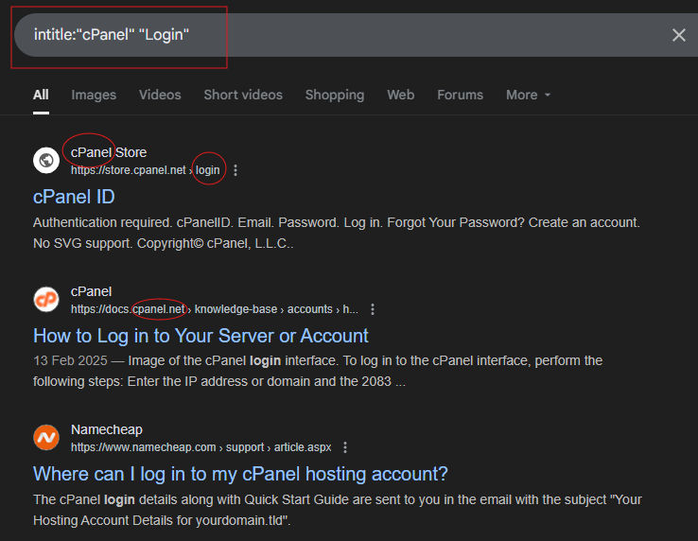

* inurl:indexFrame.shtml "Axis" - Advanced search operator

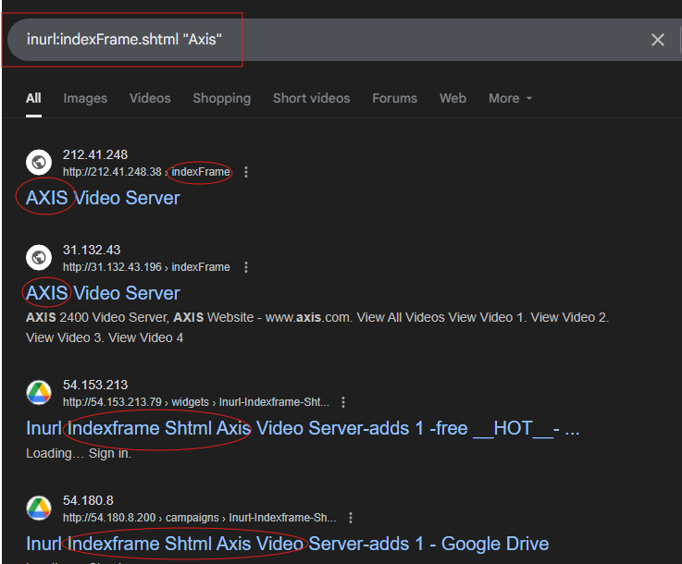

* filetype:sql "dump" "backup" - Advanced search operator

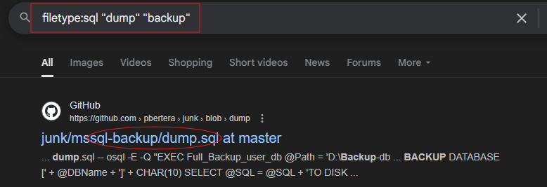

* intitle:"SONY Network Camera" - Advanced search operator

